Integration of Jenkins with Key Cloak for SSO

|  |  |  |  |
| --- | --- | --- | --- |
| Documents Name | Version | Prepared By | Reviewed By |
| Integration of Jenkins with Key Cloak | v.01 | Vikat Patil |  |
|  |  |  |  |
|  |  |  |  |
|  |  |  |  |

Contents

1 Keycloak as a Identity Provider For Jenkins 2

1.1 Step 1 : Create a keycloak client in a realm 2

1.2 Step 2 : Copy the keycloak.json 3

1.3 Step 3 : In Jenkins, Configure authentication 4

1.4 Step 4 : In the Jenkins global settings page paste the contents from Keycloak Json. 4

1.5 Step 5 : In the Security Realm activate the security realm of the plugin 5

1.6 Step 6 : Login into Jenkins 5

1.7 Step 7 : Keycloak would redirect back to Jenkins 6

# Keycloak as a Identity Provider For Jenkins

The following example may be useful if you're using Keycloak as a Identity Provider.

Steps to configure Jenkins with Keycloak

## Step 1 : Create a keycloak client in a realm

Lets call the realm 'Adopt' and the client 'jenkins'  
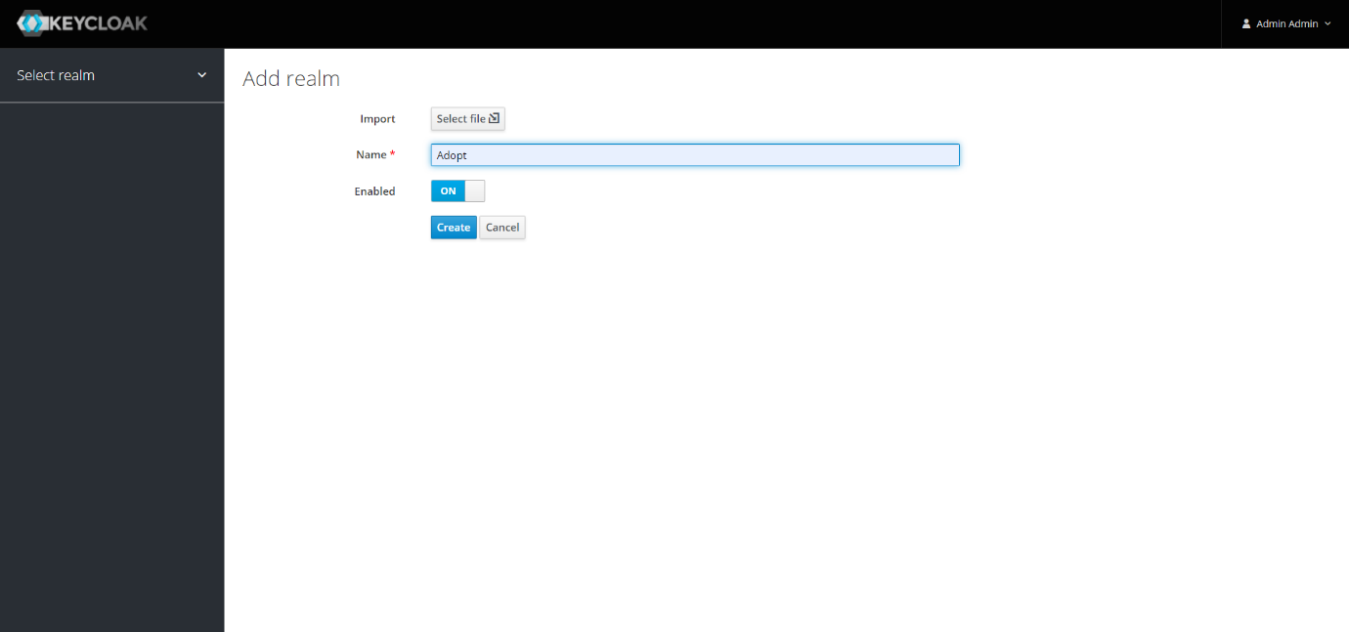

Create the client accordingly

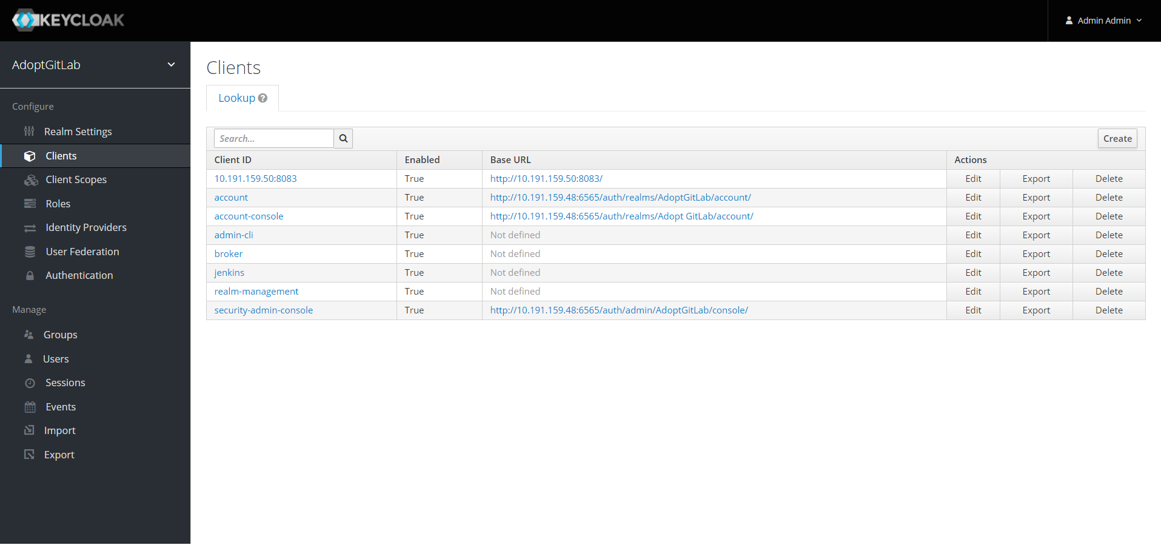

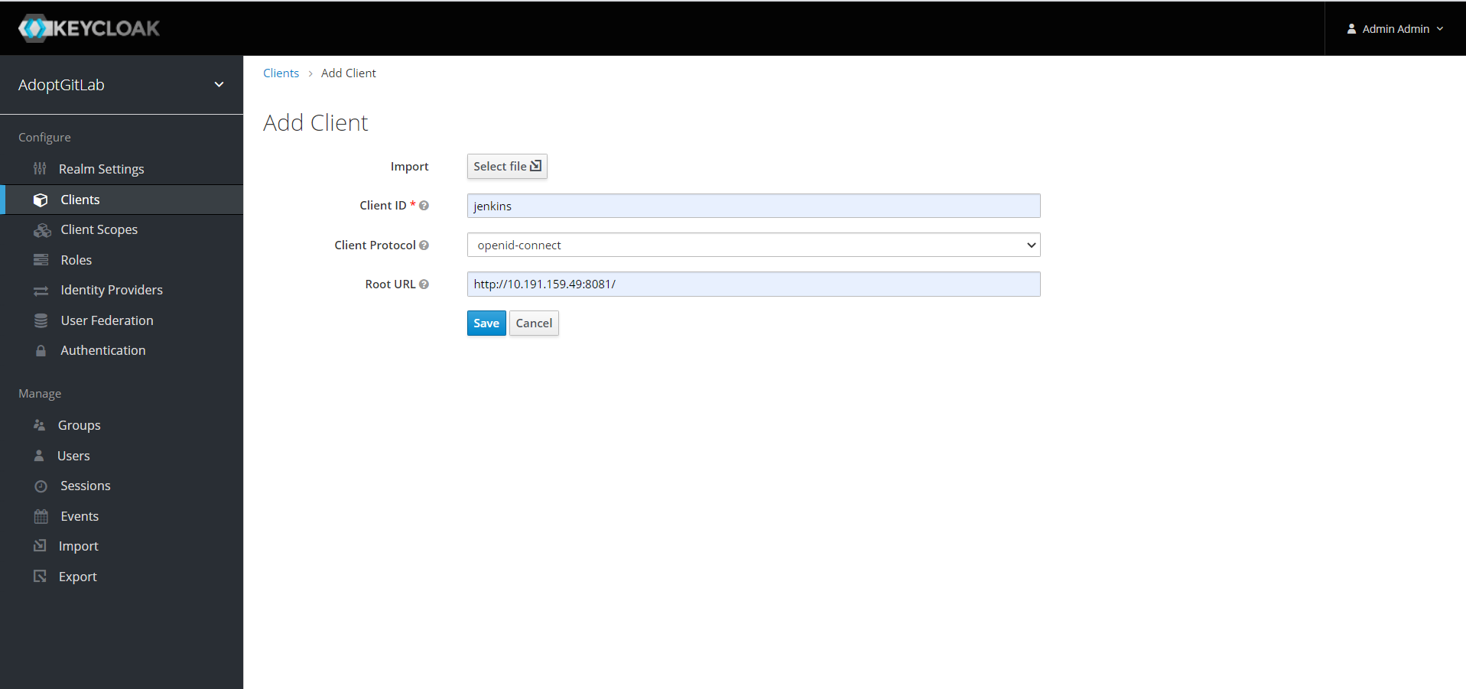

Also make sure sample users are also created, in this case I have created user1.

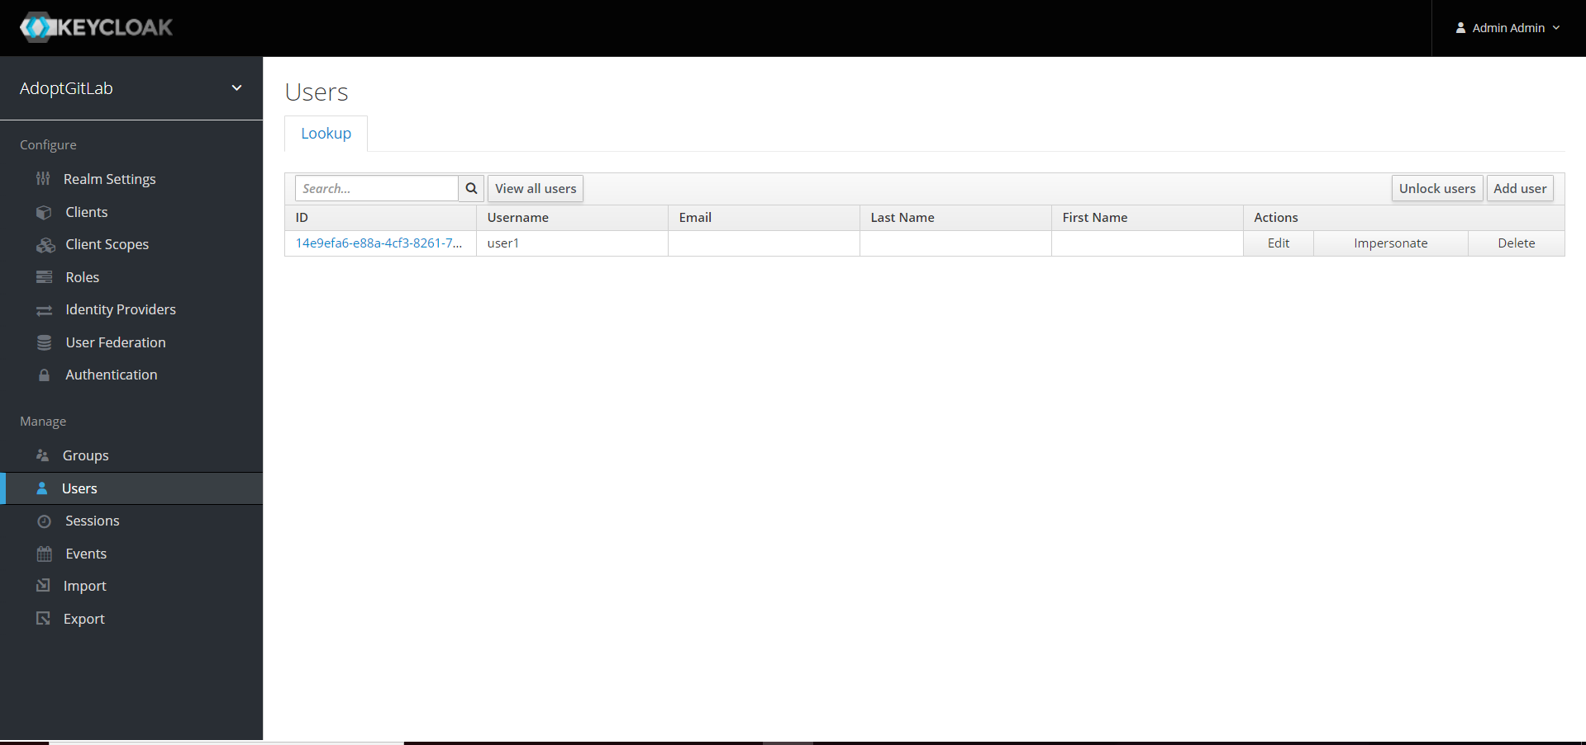

## Step 2 : Copy the keycloak.json

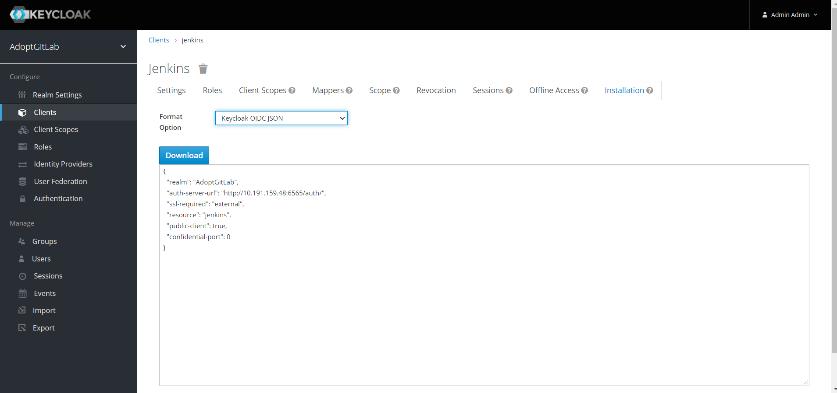

## Step 3 : [In Jenkins, Configure authentication](https://docs.sonarqube.org/latest/instance-administration/delegated-auth/)

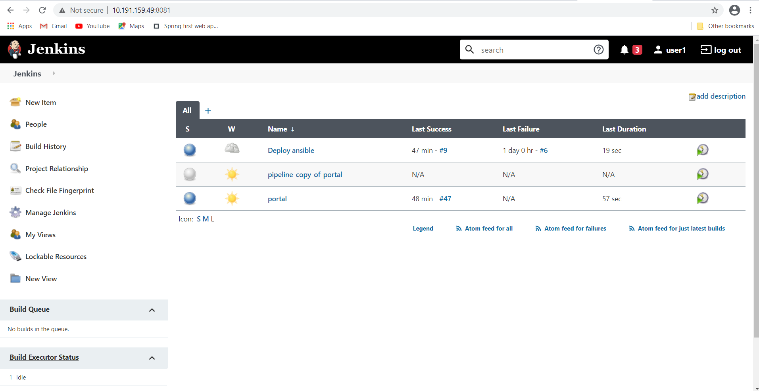

## Step 4 : In the Jenkins global settings page paste the contents from Keycloak Json.

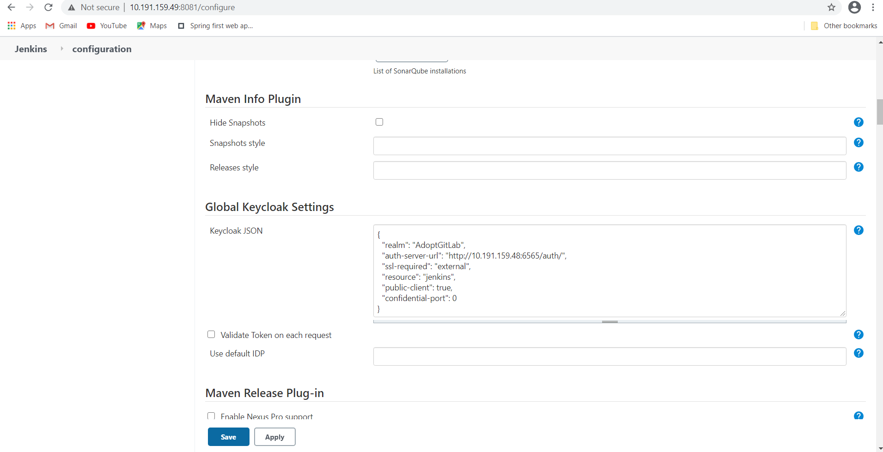

## Step 5 : In the Security Realm activate the security realm of the plugin

#### **D:\screens\screen7.png**

## Step 6 : Login into Jenkins

User would be redirected to keycloak for authentication

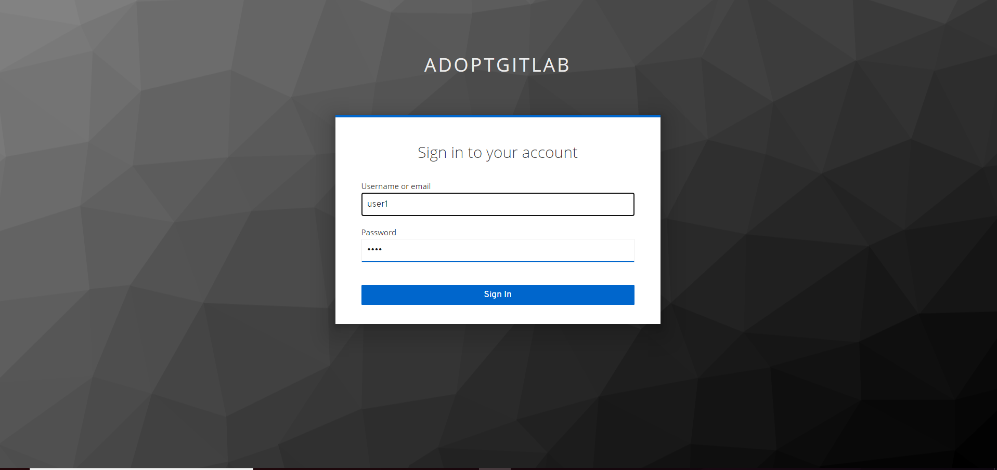

## Step 7 : Keycloak would redirect back to Jenkins

User would be redirected back to callback URL

  
